Name: ________________________________________ Date: _____________

*Remember: $D= \frac{m}{V}$*

**Density Practice**

1. 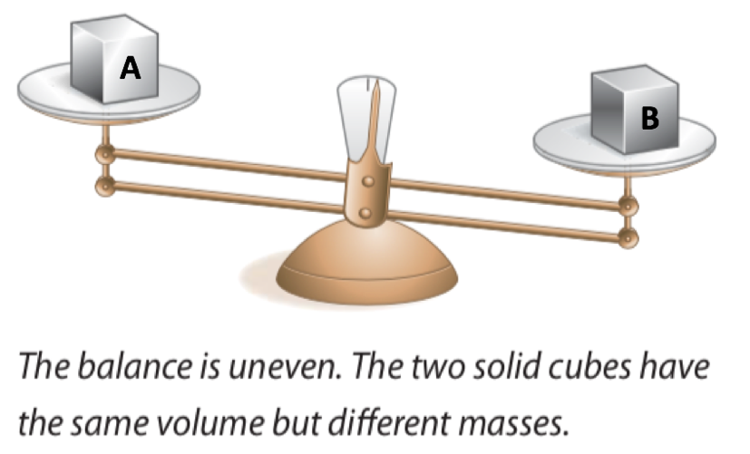Which of these two objects (A or B) has a higher density? Explain how you know using the words matter, mass, volume, and density.
2. Draw a particle diagram for objects A and B from question #1

Object A Object B

1. Which of these two objects (A or B) has a higher density? Explain how you know using the words matter, mass, volume, and density.

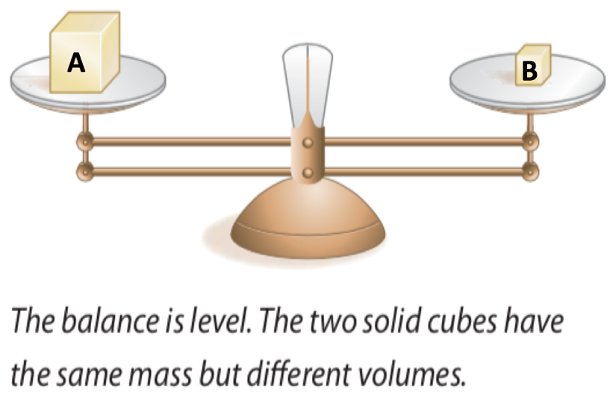

1. Draw a particle diagram for objects A and B from question #3.

Object A Object B

SHOW YOUR WORK!!!!

1. 306.0 g of liquid mercury is poured into a graduated cylinder and measures exactly 22.5 mL. Based on this information, what is the density of mercury?
2. The density of ethyl alcohol is 0.789 gm/mL. What is the mass of 200.0 mL of ethyl alcohol?
3. Find the mass of 250.00 mL of benzene. The density of benzene is 0.88 g/mL.
4. A rectangular block of copper metal has a mass of 1896 g. The dimensions (measurements) of the block are as follows: Length: 8.4 cm, Width: 5.5 cm, Height: 4.6 cm. What is the density of copper? (Hint: Volume of a rectangular block = L x W x H)
5. 28.5 g of iron is added to a graduated cylinder containing 45.50 mL of water. The water level rises to the 49.10 mL mark. From this information, calculate the density of iron.

1. Using the data given below, determine the VOLUME of the liquid in the beaker. (This will take several steps! – use extra paper if you need more space)

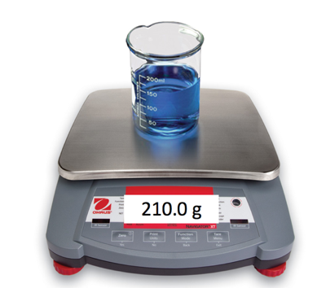

|  |  |
| --- | --- |
| **Mass of EMPTY** beaker | 89.5 g |
| **density** of **liquid** in beaker | 0.8 g/mL |